Deadlines and submission information listed on Canvas
Total Points: 25 Points
Problem 1 [10 pts]: Schmidt Coupler
The mechanism on the left, called a Schmidt coupler, is used to transmit rotational motion between 2 parallel shafts with small offset. Watch the following videos:
https://www.youtube.com/watch?v=PKXc7EzgJh4
https://www.youtube.com/watch?v=-ymq2IkL4aI
In this problem, assume that the input and output shafts cannot translate, and can only rotate (as seen in the second video)

- From the videos, how many degrees of freedom do we expect in this mechanism? Explain. (1 pts)

- Sketch an equivalent kinematic diagram, with links, joints and ground clearly identified. Assume both the input and output shaft are fixed in position with respect to ground but allowed to freely rotate.
(3 pt)

- Calculate the degrees of freedom making no special assumptions. (2 pt)

- Does the computed DOF match the DOF observed? Explain the difference. (1 pts)

- How do we correctly compute the number of degrees of freedom in this mechanism? Do it! Identify the kind of degrees of freedom. e.g. translation vs rotation (2 pts)

- If the additional links do not contribute to the degrees of freedom, why are they still included in the mechanism? (1 pt)

Problem 2 [10 pts]: Mechanism Analysis
Watch a video of the mechanism below
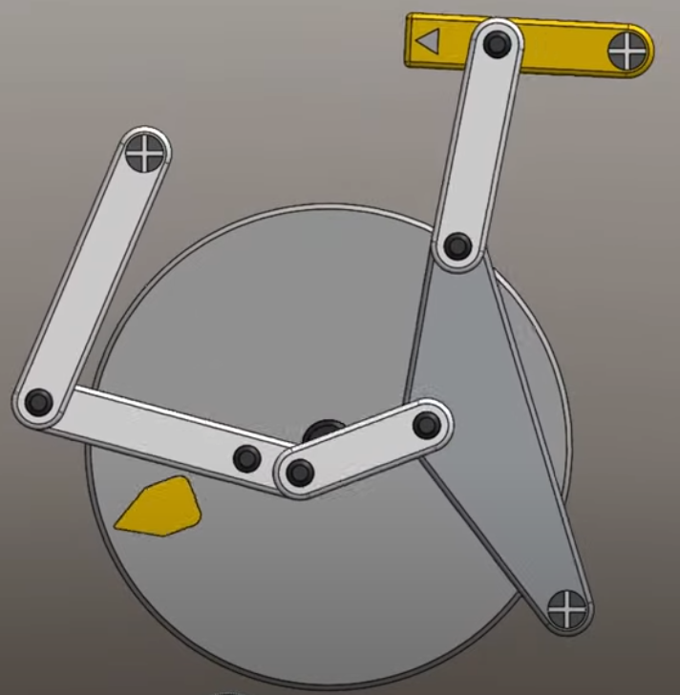
https://www.youtube.com/watch?v=ahFrHYJrorE&t=106s

- From intuition and experience, how many degrees of freedom do we expect from the mechanism? Explain. (4 pts)

- Draw a kinematic diagram and analyze the links and joints and DOF of this mechanism. (6 pts)

Problem 3 [5 pts]: Linkage Treasure Hunt
Once you know what to look for, you realize that linkages are everywhere, and we interact with them every day. A basic skill of mechanical design is dissecting the structure and functionality of real world mechanisms. Practice this skill: Find and analyze a planar linkage that you use or see everyday. Pick a mechanism that we did not discuss in class. These linkages should not include gears or cams. For
example, on my way to work today, I passed by a person using a hatchback trunk on their car, a collapsible bike rack, and an emergency fire escape.
Hand in 1 page that contains the following:
• Get a picture of the linkage mechanism (Not a schematic/graphic).
• A paragraph describing the purpose of the mechanism and how it works,
• Make a kinematic diagram of the linkage in two different configurations. If there are multiple parallel mechanisms, pick one to describe.
• Use the formalism developed in class to identify grounds, links and joints.
• Calculate the degrees of freedom. Identify what the degrees of freedom are. Do the results agree with the predicted functionality?

You will be graded of effort and accuracy

Select one of the following options:
- My answer was created by a Gen AI algorithm, and I have not modified it
- My answer was created by a Gen AI algorithm, and I have made some minor changes.
- My answer was created by a Gen AI algorithm, and I have made major changes.
- My answer was created solely by myself.
- If I used Gen AI, I used ___ (name of program).

